CEN 4010 Fall 2019

FAU Daily

Group 14

Mark Rothberg- Project Manager/Team leader

Marcus Golding- Scrum Master

Wayne Solomon- GitHub Master

All- Development Team

Date: 12/2/2019

History Table:

12/2/2019

Last Edited: 12/1/2019

**Milestone #3 Updated Information**

**Executive Summary**

The following is a summary of a senior project to create a web system based on the Campus Snapshots project outlined and provided in the class but under the name FAU Daily.

This project aims to create a social/news environment to the benefit of campus life and recreation including upcoming events and real time updates as opposed to exclusively highlighting future events. It will also provide an avenue to report and bring attention to smaller scale issues around the campus which include, but are not limited to, overflowing trash, fallen branches, classroom issues, etc.

This website is primarily targeted to the entirety students with an attention to faculty. The goal is to provide an avenue for anyone to report issues with the campus or events.

**Competitive Analysis**

|  |  |
| --- | --- |
| Competitor: FAU Student News | Yours: FAU Daily |
| Upcoming events are posted | Upcoming events are posted as well as current events |
| Can RSVP with Handshake | Can RSVP with Handshake by linking to their website |
| The News is updated every day | The News is updated per minute |
| Posts threats and sends text messages to all students phones | FAU Students are able to post information regarding plumbing problems, construction problems, potential threats, or any dangers to alert other students. |

The planned advantages that FAU Daily has over the current Student News is that FAU Daily has updates per minute of everything that is going on at school. Anything that is slightly important will be posted on the website. When school starts all of the events will be posted on our front page. We will also have postings of people on campus such as the school performers that are playing in the breezeway or student organizations that are having events at that exact moment. This is dedicated for the student that doesn’t know about any event and wants to go to something in the moment.

**Data Definition**

The user will be able to access the website in order to view the news. The user will be able to make an account to post news onto the website. The profile of the user will have a spot for a picture of the user, a name slot, and the about section. If the user doesn't post a name for themselves they will be given a randomized number next to “FauUser #”. The user will be able to only edit their posts. The user will not be able to edit any other user’s post or any website information. So If someone posts *“Hellow World”*, another user won’t be able to edit it to say *“Hello World”*. The user won’t be able to edit what goes onto each page. The owner of the website will have full access to everything.

These are our definitions and acronyms that we use for our website.

FAU Daily: FD

News: Anything and everything that is occurring on campus

Database: The collective information of all the news stories.

Work in Progress: WIP

**Overview, Scenarios and use Cases**

This project will emphasize the needs and wants of the average FAU student ranging from the technically savvy to those who are not all too familiar with sites outside of social media. The goal is to be accessible to those who see an issue and are looking to quickly report it. Those who are interested in various events around campus will be able to quickly and efficiently locate said events without requiring any navigation.

Users will create an account using their FAU email (preferably) and a password in order to submit a post to the complaints board. Viewing will not require a password. The home page will contain a timeline of upcoming events.

**High-Level functional Requirements**

1) Home page with currently updating news. The User will be able to access the home page to view the news. The User will be able to post to the home page. The User will only be able to edit their post and will be able to update it as needed.

1) A login for FAU students using a separate username and password. The User will be able to make an account for the website in order to post to the site.

1) A profile page where you can edit your about me, name, and account information.

**List of non-functional requirements**

The system should allow the user to use Internet Explorer, Mozilla Firefox and Google chrome. There won’t be a dedicated mobile version of the website. There shouldn’t be too much of a load on the server. There will be relatively secure accounts with password management. The website will be stored on the lamp servers. The website will be available as long as the server will host our group. There will be some code safe guidelines if there are any faults.

**High-level system architecture and database organization**

We will be using Visual Studios, Sublime, Atom, Java, JavaScript, HTML, CSS and C++. We will support Google Chrome, Internet Explorer, and Mozilla Firefox. We will mainly use CSS and html. Any external code that we would use would be from YouTube, general coding help sites or bootstrap.

The main features that are apart of this project can separated into 4 categories being the accounts, live updates, posts and timeline. The accounts will require a server to hold them all. To accomplish this, we can use the lamp server given to us by Florida Atlantic University. To classify a login, the user must define a username, password. The user will have an addition option to add a picture to their account if they choose to do so. For live updates and post, we can use a simple interface similar to other social media and blog sites. The post can only be made by users with accounts and each post will have a reply section paired with a like button. The post or blog will have a text and/or picture entry. Lastly, the timeline will be all the posts that have been either recently made or the most popular indicated by the number of likes.

Log in

Lamp server

Username and password

Picture

Live update

Post format

User to post

Post section

Picture

Text

Timeline

Most liked or most recent at the top

**High-Level UML Diagrams**

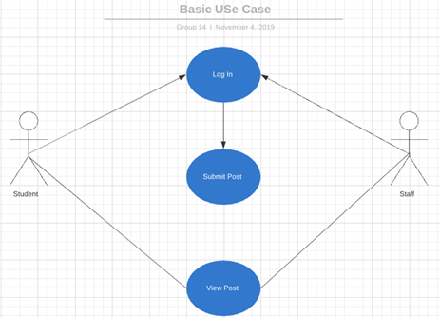

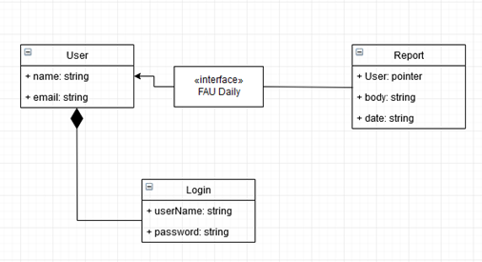

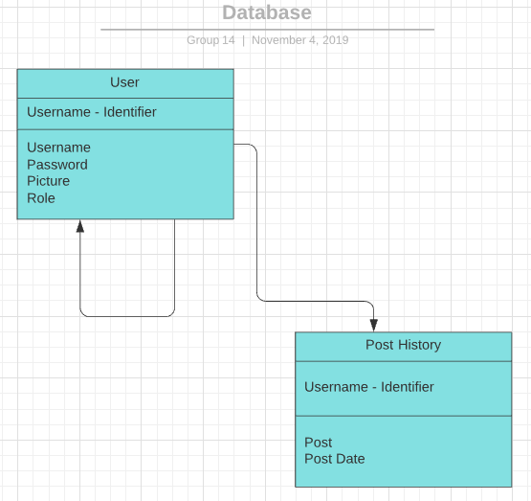

**Identify actual key risks for your project at this time**

1) Skill risks: There shouldn’t be able risks for the User. The User will have to be able to use the Internet. The User will also have to understand how to Post onto the website. In order to show the User how to post on the website, there will be a help tab which will explain exactly how to post onto the website. There will also be pictures displaying each step.

2) Schedule Risks: The only problem that would arise is for the Calendar page and Student Organization Page. The Administrator will have to check the webpage for anyone who wants to post to the Calendar. The Administrator will also have to be in contact with the Student Organization in order to post to that page with relevant information. In order to fix this, the website will be able to send an email to the Administrator for every request from the User. The Administrator will be able to enable permission from the email for the post of the User.

3) Technical Risk: There shouldn’t be any Technical Risks that involve this assignment. The only problem that could possibly arise would be that there could be a power outage that requires the website to be updated. If this were to occur the solution would be that within the code there will be a failsafe. The failsafe will be activated and the website would be reset as soon as the server is put back online. This would be a server side risk which the Owner of the website wouldn’t be able to do much about since the website is hosted on a Lamp server.

4) Teamwork Risks: This team has great teamwork and has shown to be able to work very well under pressure. This team doesn’t have any problems so far with teamwork. In order to solve any problem regarding teamwork, the team would meet with the Leader of the section to discuss the problem. Once the problem has been understood the Leader would handle the situation.

5) Legal/content Risks: The only risk would be the fact that this website will be competing with Fau Student News. Even though we are posting different information from them, they might think we are copying their website. In order to solve this problem we can change up more of the website, but we aren’t using anything that they have. The entire backend of the website is also different from theirs so they can’t copy strike this website.

6) Project Risks: Due to our SQL Database server being un-usable, the current risk to the project would be that posts wouldn’t be saved to the project. Once the Database is fixed then this risk would be fixed. There doesn’t seem to be any other project risks.

**Milestone #4 Updated Information**

**Product Summary**

The product’s name is FAU Daily. The major committed function that our product focuses on is posting information to the news blog page. We have tested this function and it has been approved by the Product Owner. It is very easy to post to the page and easy to navigate. The unique feature is that you can directly post to the website from the home page without the need to register. This allows users to post anonymously and to post instantly.

URL: <http://lamp.cse.fau.edu/~cen4010fal19_g14/index.html>

**Usability Test Plan**

Test objectives:

The goal is to be able to post a blog onto our home/temporary page

Test plan:

To test this we will use a separate computer to represent a “new user” to see if we can get to the website. Then, make sure that the user can see the post that have already been made. Following that, we will test to see if the user can create a post/news article using the given interface. Lastly, check to see if the created post is showing on the website.

Questionnaire form:

Answer all questions on the scale of: Strongly Disagree, Disagree, Neutral, Agree, Strongly Agree

* You were able to access and navigate through the website?
* You were able to create a post comfortably?
* You were able to see the post on the temporary site?

**QA Test Plan**

Test Objectives:

The goal is to be able to create and post a blog onto our home page

Hardware and Software Setup:

Windows and Mac OS

Google Chrome and Microsoft Edge

Feature to be Tested

Website posting feature for adding in content relating to FAU Daily news

Actual Test Cases:

1. Is the website coming up indicating that our server is working?
2. Are we able to create a post using the user interface?
3. Can we visibly see the listing on the temporary website?

Google Chrome Tested:11/17/2019

|  |  |
| --- | --- |
| Test 1 | Pass |
| Test 2 | Pass |
| Test 3 | Pass |
| Summary | Website in its infancy works as intended |

Microsoft Edge Tested:11/17/2019

|  |  |
| --- | --- |
| Test 1 | Pass |
| Test 2 | Pass |
| Test 3 | Pass |
| Summary | Website in its infancy works as intended |

**Summary of Instructor’s Feedback Regarding Milestones 3 and 4**

Regarding Milestone 3 the instructor thought we did a good job. The first comment is about our data definition. We don’t have too many data definitions or different definitions since we don’t need to use too many. The second comment is about the functional requirements. We fixed this section by updating all of the information with everything we focused on for the current website. The third comment is to revise the non-functional requirements which we did for this milestone. The fourth comment is about the system architecture in the form of UML. The Fifth comment is about risks strategies. We updated the risks to include Project risks. The sixth comment was about the demo. We made a demo for Milestone 4 and also for this milestone. The seventh and final comment from milestone 3 is to do with formatting. We noticed that there was formatting issues on the submitted pdf version of the document, but whenever we fixed it and reuploaded it to canvas, the issue never changed.

Regarding Milestone 4 the instructor again thought that we did a good job. The first comment has to do with the product summary not reflecting the functional requirements. We agreed that they weren’t exactly the same, so we fixed this issue in milestone 5. The second comment has to do with the QA test needing to be more detailed. This was noticed and updated in milestone 5. The third comment had to do with input validation. We didn’t quite understand what we had to do for this section as the comment was more of a definition. We made the demo with a voice for the final presentation and demo. We originally forgot to include the voice in the milestone 4 demo.

**Screenshots of demo from final presentation**

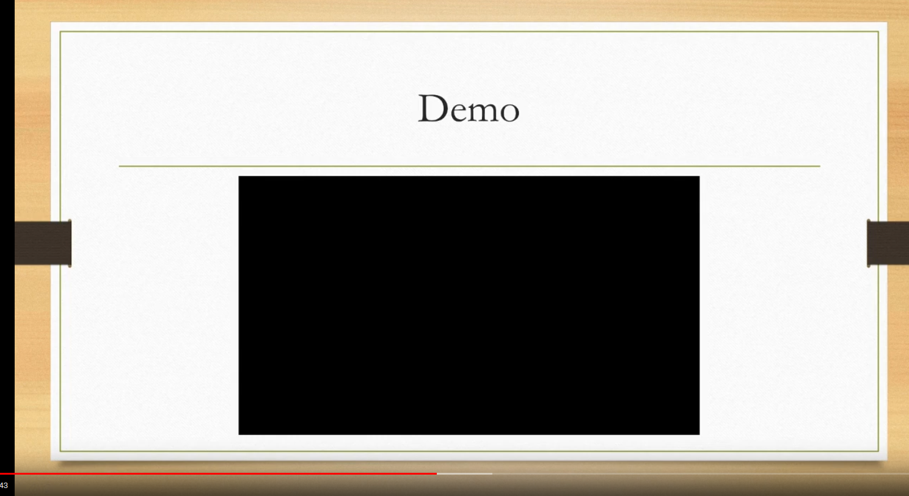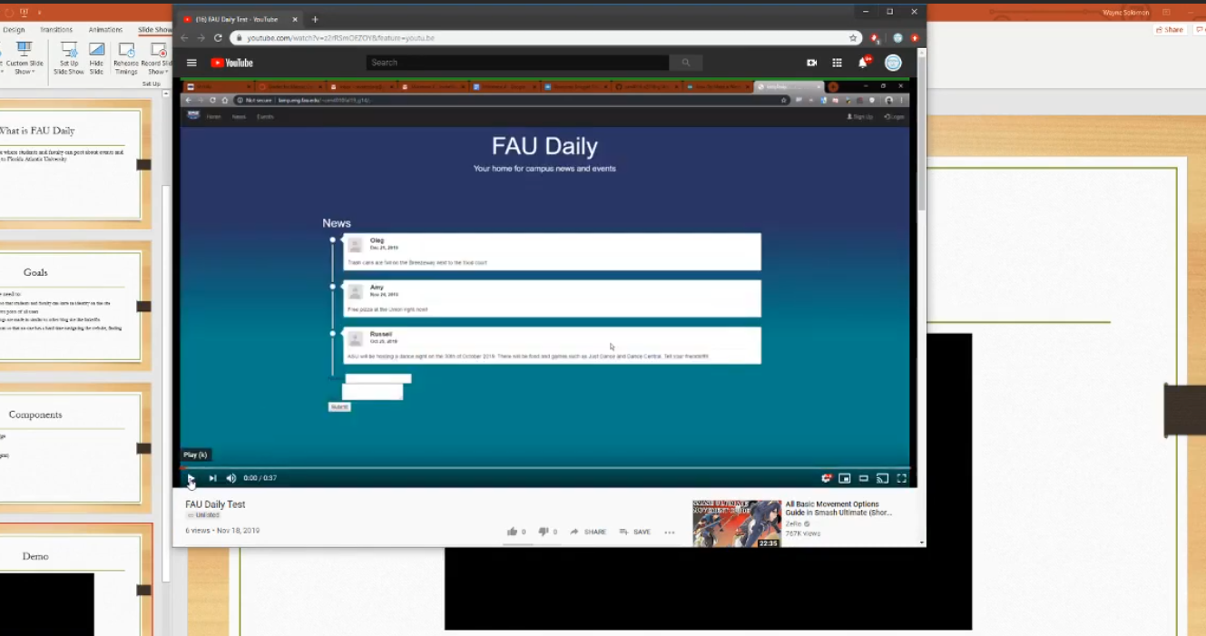 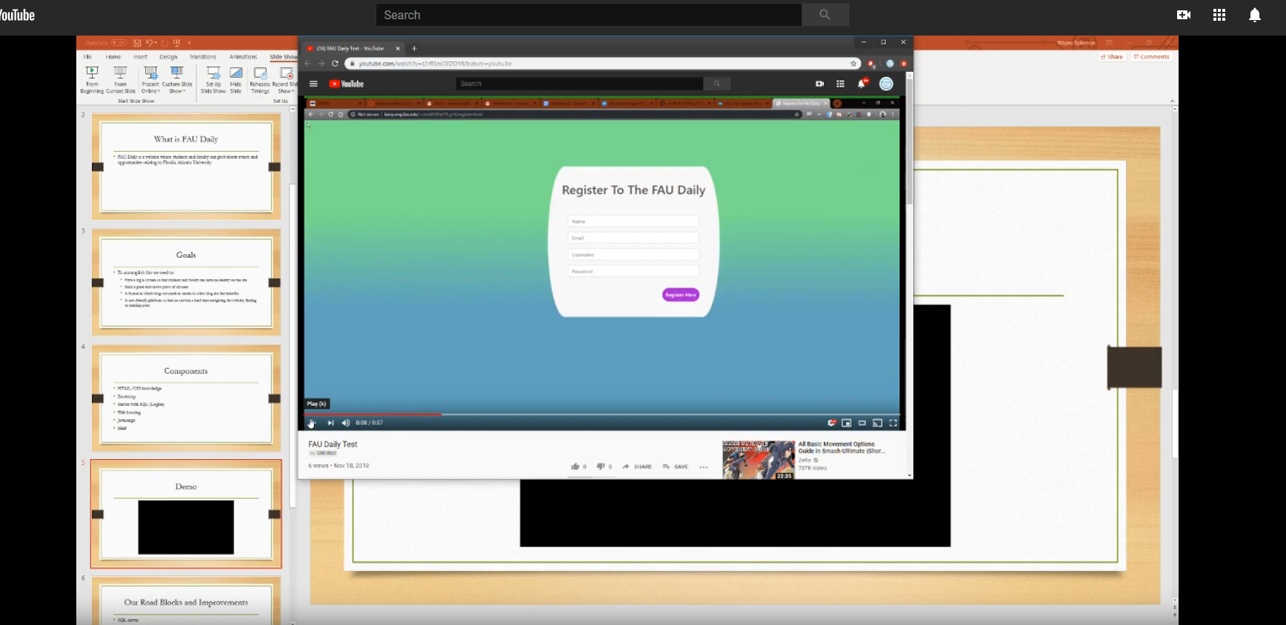

**Google Analytics**

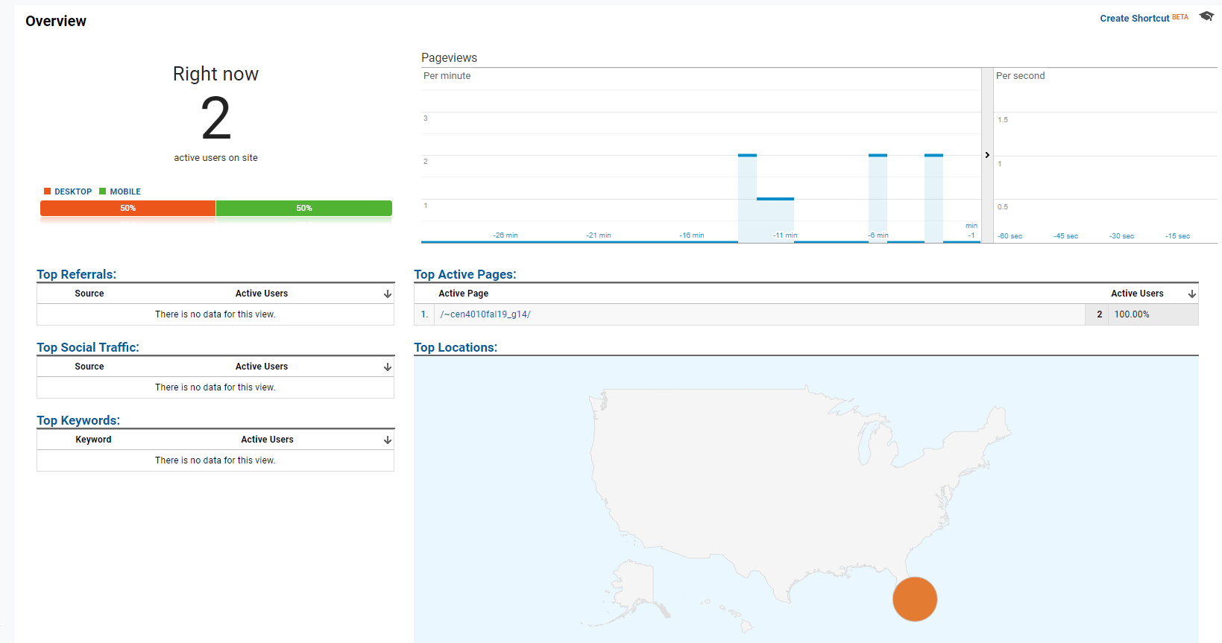

**Team Members Contribution**

1. Each member contributed Equally to the project. Everyone gets equal points toward the project.
2. Mark organized meetups and designated roles for each section of the project. Wayne focused on the code and updates to the powerpoint presentation while also working on the milestone documents. Marcus focused on the website html and worked on the milestone documents as well. Mark helped each member with anything, but so did wayne and marcus. Basically everyone contributed to each section of the website equally along with writing the documents and coding the website.
3. Mark uploaded about 1 to 2 times Wayne uploaded 1 to 2 times and Marcus uploaded 2 to 5 times. Marcus was the best at uploaded to GitHub so we designated him to upload to GitHub.

**Post-Project analysis**

The main challenges that our group faced were finding time to work together and database restraints. Our group took an extended amount of time trying to find a time to work together on these milestones. Once we found a time then we had to find a location to meet up which also created some problems. We ended up deciding to just work on campus at Engineering East. We also faced some database restraints since we didn’t have any access to the back-end of the website. Our information to login to use SQL didn’t work so we ended up having to use pseudo code for the majority of that section. Something that we would do next time regarding finding time would be to plan ahead of time and plan dates that we would be off from work to meet together. In order to solve the database restraints as a group we would send more emails beforehand and hope to get a response on time in order to gain access to the database back-end side. A feature that we had finished was setting up the website and creating every page necessary for the website to be complete. A feature we would have liked to finish if we had the database side(back-end) would have been the setting up of profile and account information along with saving the information people would post onto our website. Some knowledge that we gained were skills relating to website design such as: Html,css, and group structure. Since a website made with a group is much easier to be done, having set roles is much easier. We also learned that it is always better to plan ahead so that some risks wouldn’t become problems in the future.

**Final Presentation Powerpoint and Demo Youtube Link**

Link: <https://www.youtube.com/watch?v=kazg9Mdwy4M&feature=youtu.be>

Trello Workspace: 